1. App Settings Section contains all the connection and application info. Text

   Description automatically generated
   1. Set the <username> and <password> fields with the account being used for the migration
      1. This account must be a M-Files account, not a user account with MFA
   2. Update the <server> and <vaultGUID> fields for the vault you need to connect to (by default set to QA Connection info)
   3. <StartFolderLocation>, this is the folder that needs to be migrated.
   4. <ExcludedExtensions>, contains a pipe delimited list of extensions to exclude.
2. Default Properties section contains all the properties that will be default across everything migrated.
   1. At a minimum this needs to include the Class and filename information.
   2. For each property you want to default you have to add a Property Section
   3. Graphical user interface, text

      Description automatically generated
   4. There are a few reserve words that will retrieve information at processing time:
      1. {filename}, sets the value to the name of the file
      2. {modified}, sets the value to the modified date of the file MM/DD/YYYY
      3. {path}, sets the value to the path of the file (everything after the start folder location
      4. NOTE: these reserve words can only be used for text fields or date fields respectively.
3. Folder level section, contains information about data to be extracted from the folder structure
   1. If you want to search the vault for a value matching the folder name, the folder level and id or alias must be specified, and has condition = false
   2. For example if the first folder is going to be a well name, you can set the settings like this:
   3. Text, letter

      Description automatically generated
   4. If you want to set properties conditionally based on a specific folder value, conditional values can be added.: For example
      1. The below settings will set the value of property specified in the id or alias respectively based on conditions in the value conditions section
      2. If multiple folder values have the same value to be set, they can be delimited by a | symbol
      3. In the below example if folder level 2 has the following value:
         1. AFE it will set the DWF Category to General
         2. Completions, OR, Production OR Workover, it will set the DWF Category to Completion and so on…

1. Conditional Properties section is used to set properties based on values that are selected for other properties , such as setting the subcategory to a certain value based on the value of category. The processing order fields sets the order in which these conditional properties are executed (for example if the category needs to be set before the subcategory)
   1. This section is best used for properties with a Parent-Child relationship.
   2. It logically reads: if parent property has value x set child property to Y
   3. In the snippet below:
      1. if the category =General, then set the sub category to AFEs…
      2. If the category = completion , set the subcategory to completion…
   4. Text

      Description automatically generated
   5. If there are additional conditional statements needed to decide the value, you can also include an additionalCriteria section for example
      1. If you want to set the value of the subcategory if the category field has a value of “Drilling”, however, the value of the subcategory could be different based on the value of folder level 2, you can do the following:
      2. You can specify multiple folder criteria or additional property criteria if needed.
         1. The first criteria that is met will be the one that gets used
   6. 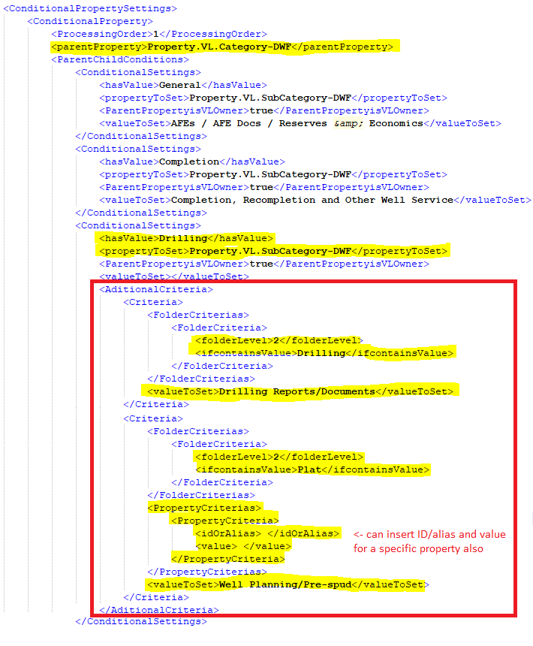
2. Concatenated properties sections only works for text fields. This allows to create a concatenated property based on text, property values, and file system properties (filename, modified date, file path).
   1. All fields must be prefixed with either, “Text:”, “Property:”, or “FileInfo:”
   2. All concatenated fields must be separated by a pipe symbol “|”
   3. Properties can use ID or Alias fields
   4. FileInfo items can be either {filename}, {modified}, or {path}
3. 